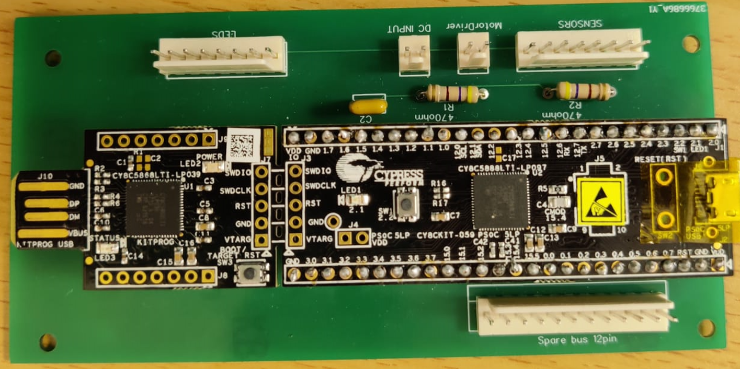

1 2

1 2

1 8

1 8

12 1

1 2

1 2

1 2 3 4 5

6 7 8 9

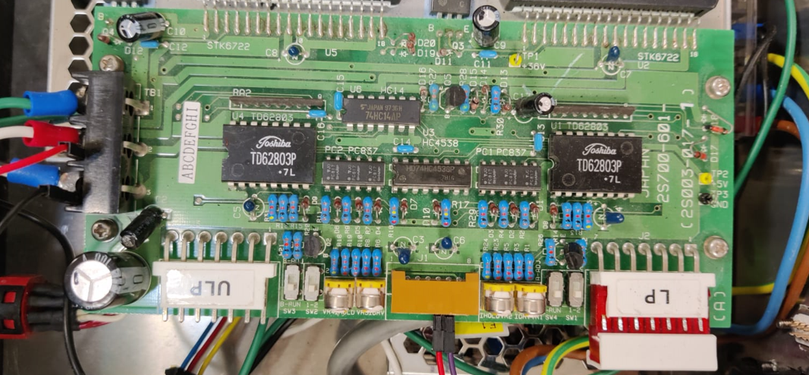

36V

5V

GRD

1 8

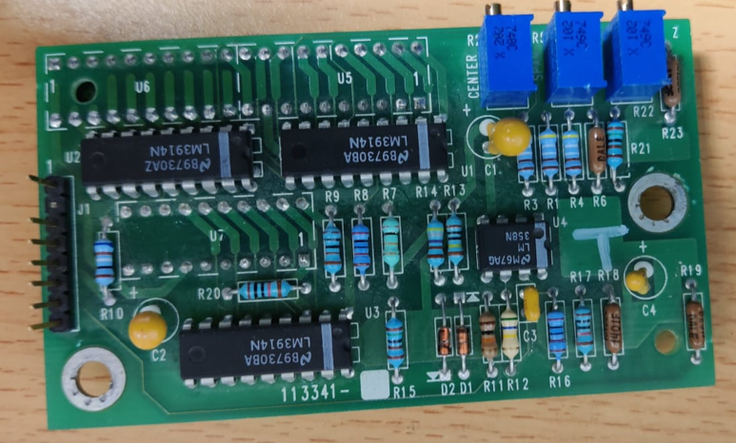

1

8

|  |  |  |  |  |  |
| --- | --- | --- | --- | --- | --- |
| Internal pinout, passive components and microcontroller | Pin's number | Board component | Pin's number | | External matching component |
| R1-2 | 1 | sensors | 1 | 5 | DB9 |
| 5V | 2 | 2 | 9 |
| MP2.2 | 3 | 3 | 4 |
| GND | 4 | 4 | 8 |
| GND | 5 | 5 | 7 |
| MP2.0 | 6 | 6 | 2 |
| 5V | 7 | 7 | 6 |
| R2-2 | 8 | 8 | 1 |
| 5V | 1 | LEDs | 1 | 1 | LEDs' Board |
| null | 2 | 2 | null |
| GND | 3 | 3 | 3 |
| MP1.6 | 4 | 4 | 5 |
| MP1.5 | 5 | 5 | 4 |
| GND | 6 | 6 | 6 |
| 5V | 7 | 7 | 7 |
| null | 8 | 8 | null |
| MP2.5 | 1 | Motor Driver | 1 | 5 | Motor Driver's Board |
| MP2.4 | 2 | 2 | 6 |
| 5V | 1 | DC Input | 1 | 5V | Power Supplier |
| GND | 2 | 2 | GND |
| MP15.4 | 1 | Spare BUS | 1 |  | Switch |
| MP15.5 | 2 | 2 |  |
| MP0.0 | 3 | 3 |  |
| MP0.1 | 4 | 4 |  |
| MP0.2 | 5 | 5 |  |
| MP0.3 | 6 | 6 |  |
| MP0.4 | 7 | 7 |  |
| MP0.5 | 8 | 8 |  |
| MP0.6 | 9 | 9 |  |
| MP0.7 | 10 | 10 |  |
| 5V | 11 | 11 |  |
| GND | 12 | 12 |  |